TAMILNADU STATE COUNCIL FOR SCIENCE AND TECHNOLOGY
STUDENT PROJECT PROPOSAL


1. | Name of the Student (s) | :
S.No | Name of the Student | E-Mail ID | Phone No.
1 | Sabareswaran.K | sabareswaran.kmech@sece.ac.in | 7639369012
2 | Balakumar B.S | balakumar.b.s2020lateral@sece.ac.in | 9600523449
3 | Bharathram.B | bharathiram.bmechlateral2020@sece.ac.in | 8870472697
4

2. | Name of the Guide | : Mr.Sathish.K
 | Department / Designation | :Mechanical Engineering / Associate Professor
 | Institutional Address | :Kondampatti(post),Vadasithur,Kinathukadavu,  Coimbatore - 641202
 | Phone No. & Mobile No. | :7402252665
3. | Project Title | :Performance Study on Draft Tube in Kaplan Turbine
4. | Sector in which your Project proposal is to be Considered | :Agricultural/Biology/Environment/Medical/Physical/Social/Veterinary  Engineering Technology (Chemical Engg/Computer Science/ I.T/ Civil/Mechanical/Mechatronics/Electrical/Electronics/Communication/ Instrumentation)  (Specify only one sector)
5. | Project Details | : (write up (max. 3 pages only) should be given for each item including justification for acquiring / fabricating equipment’s / apparatus in the budget)
5. | Project Details | i. | Introduction | iv. | Work Plan
5. | Project Details | ii. | Objectives | v. | Budget
5. | Project Details | iii. | Methodology | vi. | Any other details
6. | Has a similar project been carried out in your college / elsewhere? If so furnish details of the previous  project and highlight the improvements suggested in the present one | : | No
CERTIFICATE

This is to certify that Mr./Miss.K.Sabareswaran , Balakumar.B.S ,Bharathram.B is a bonafide final year student of P.G. Science / U.G.Engineering/ P.G. Professional courses of our college and it is also certified that two copies of utilization certificate and final report along with seminar paper will be sent to the Council after completion of the project by the end of May 2023.

Signature of the Guide | Signature of the HOD | Signature of the Principal/  Head of the Institution  (with seal)

__________________________________________________________________________
PERFORMANCE STUDY ON DRAFT TUBE IN KAPLAN TURBINE

INTRODUCTION:
Regarding balancing the needs for power consumption, hydropower acts as a regulator by responding to load fluctuations during the day and night. Conventional hydro turbines are doing a terrific job over decades since the load on the electricity system varies steadily and gradually. Modern energy use, however, has grown considerably more complex and unpredictable due to the proliferation of personal energy storage devices, transportation, and the start of different types of renewable energy to lessen carbon footprint.
As a result, the grid load changes significantly in a short amount of time. Thousands of megawatts might alter in only hours. In addition, the worldwide water circulation system is disrupted by climate change, making the fluctuation in river water levels unpredictable. The development of the new hydro power comprises looking for a solution to become more flexible in a larger operating power and head range in order for it to function as a safe renewable energy source. Pelton type hydro turbines are favoured for top high head situations due to their complete range operability, but when it comes to lower water net head, the geographical environment's constraint takes over, making Francis and axial type turbines remain quite popular. As a result, the draught tube is the focus of this paper's design and research. The draught tube is created, analysed, and confirmed using numerical simulation and model testing. The redesigned draught tube is discovered to be effectively running on a substantially wider working head range without a noticeable loss in efficiency. Additionally, no aeration, water jet, or extra assistance from foreign structures is used.

OBJECTIVES:
- to obtain a geometry that reduces investment costs
- To design and fabrication of Draft tube
- To increase the performance of the turbine
- To increase the overall machine efficiency allowing for reduced payback time.

METHODOLOGY:
The Kaplan turbine is an inward flow reaction turbine, which means that the working fluid changes pressure as it moves through the turbine and gives up its energy. Power is recovered from both the hydrostatic head and from the kinetic energy of the flowing water.

WORKPLAN:

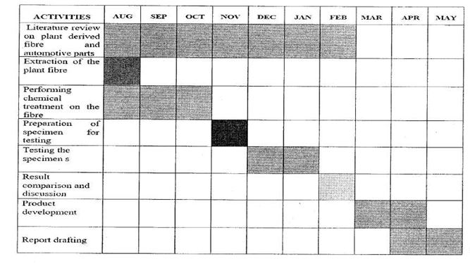

BUDJET DETAILS:

DESCRIPTION | 2022 -2023
Recurring
Consumables
Non-Recurring
Testing

